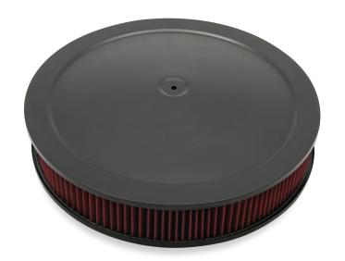

IRA RCALENE

A: air cleaner

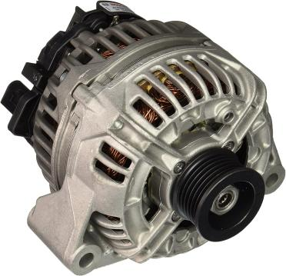

NALTAEORRT

A: alternator

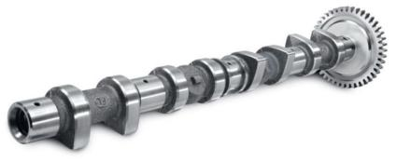

SCHTFAMA

A: camshaft

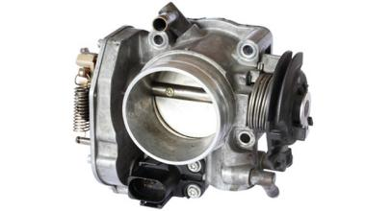

RTUBRECOAR

A:Carburetor

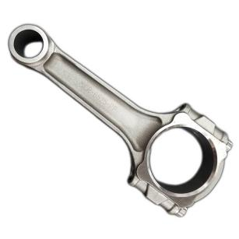

TNTINCCOGE DRO

A:connecting rod

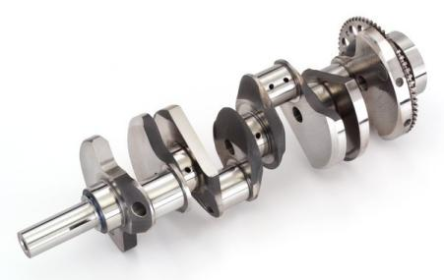

NTCKRSFAHA

A:crankshaft

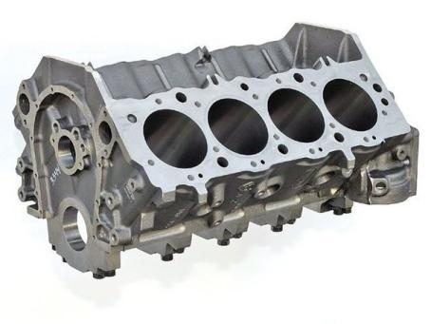

DELCIYRN CKBOL

A:cylinder block

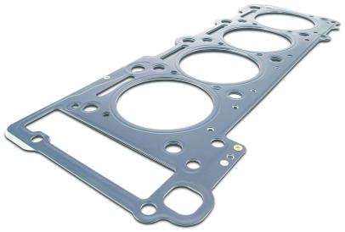

NREYDICL DHEA SKAETG

A:cylinder head gasket

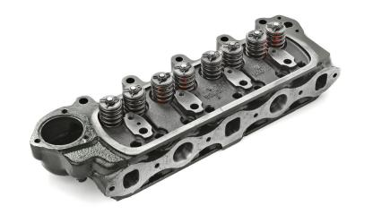

RINYCLED EAHD

A:cylinder head

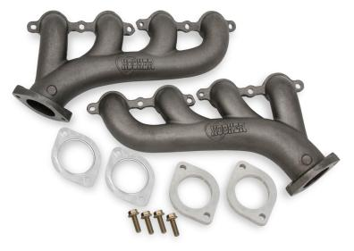

TXHASUE FLINMOAD

A:exhaust manifold

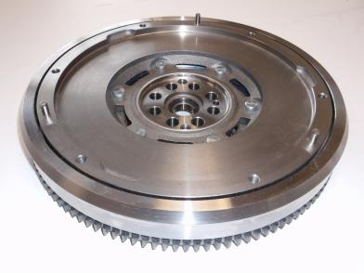

LELEHWYF

A:flywheel

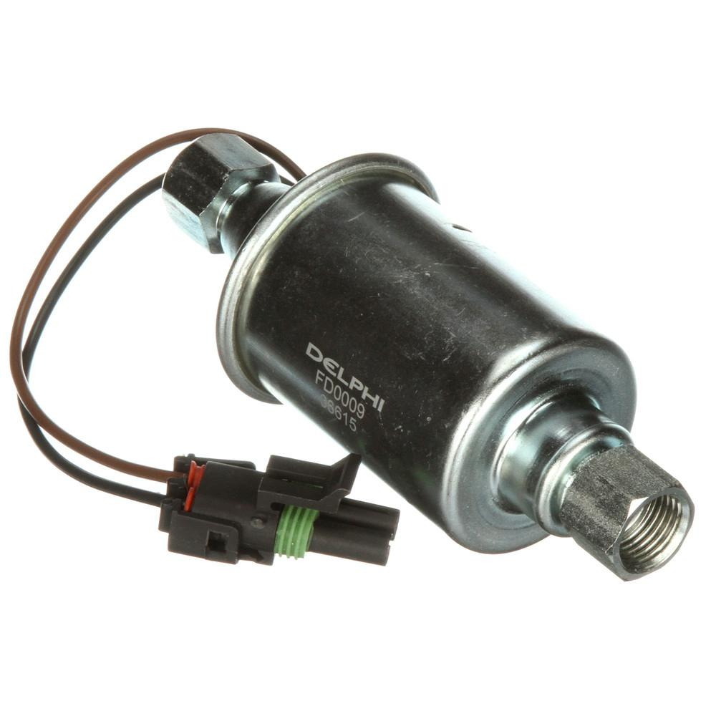

EFUL PPMU

A:fuel pump

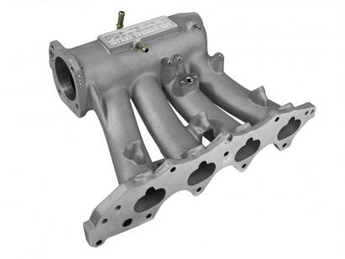

KNITEA DNAIFMOL

A:intake manifold

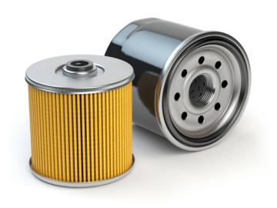

ILO RIFTEL

A:oil filter

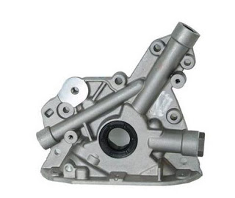

OLI MUPP

A:Oil Pump

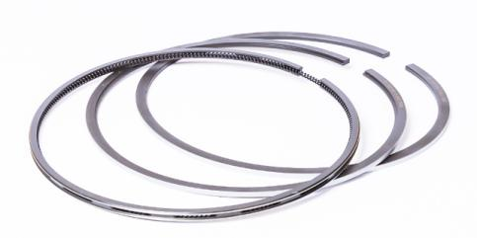

NTOSIP GNRIS

A:piston rings

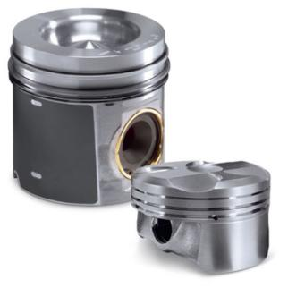

TOSPIN

A:PISTON

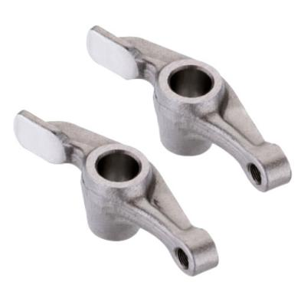

CORREK RMA

A:rocker arm

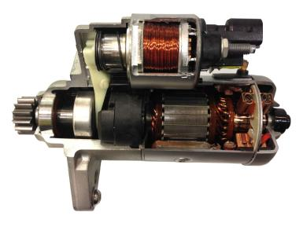

TTARRES OOTRM

A:starter motor

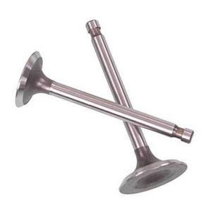

SAVVLE

A:valves